

BETA -BONKERS
Lunch at “L’Osteria at Ellender estate” Glenylon
Sunday 28th JUNE 2015
Starting from BP ROCKBANK and finishing for lunch at L’Osteria Ellender Estate
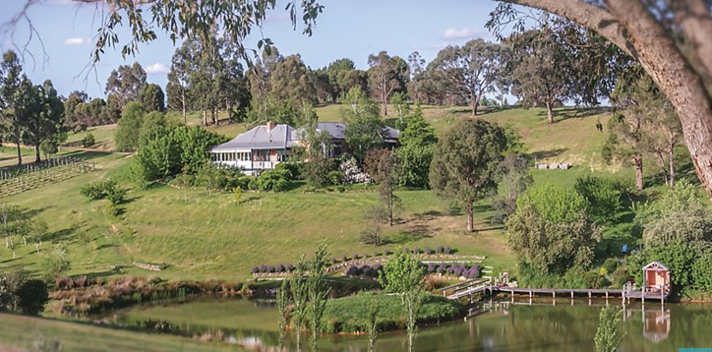
260 Green Gully Road Glenlyon, Victoria 3461 T: (+61) 3 5348 7785

Two Course (Entrée, Mains,) $38.00 per person
- Wine tasting to commence the festivities
- Tasting boards antipasti mixture to share as an entrée
- Main course from the wood fired oven is a selection of Pizza’s
- Salads provided with all meals.

COST: $38.00 per head for Lunch. (You pay on the day)
RSVP: By midday Thursday 25th June via the booking form.
START TIME / LOCATION: 10am for a 10.30am departure
Meeting Point: BP Servo, 1789 Western Freeway, Rockbank VIC 3335 (Mcdonalds Café for breakfast) Angelo Monteleone: 0430508509

BETA BONKERS
BOOKING FORM

NOTICE TO PARTICIPANTS:
This event is being run under the auspices of the Australian lancia Register. It is expected that drivers will adhere to all road rules including speed limits and blood alcohol limits and at all times drive in a safe manner.

Australian Lancia Register
L’Osteria at Ellander estate” Glenylon SUNDAY 28th June 2015
BOOKING FORM

Member name:
Membership number:
Mobile telephone number:
Number of Attendees:
Names of Attendees:
1.
2.
3.
4.

Car details: Rego: Model/year: Colour:

Please scan and email this page before Thursday 25th June 2015 to angelo@covertel.com.au
Or call me to accept your reservation.

Angelo Monteleone: 0430508509

START TIME / LOCATION: 10am for a 10.30am departure
Meeting Point: BP Servo, 1789 Western Freeway, Rockbank VIC 3335 (Mcdonalds Café for breakfast) Angelo Monteleone: 0430508509
Angelo Monteleone: 0430508509

